

**A PROJECT REPORT**

**Happy Sweets & Bakery**

Submitted in partial fulfillment of the requirement for the 1st Semester of

**MASTER IN COMPUETR APPLICATION**

**TO**

**RK UNIVERSITY, RAJKOT**

## Submitted By

### Name : Kamani Rutvik Enrollment No : 22SOECA21028

## UNDER THE GUIDANCE OF

## INTERNAL GUIDE

## DR. HOMERA DURANI

## Assistant Professor,

## RK University.

## Rajkot



**SCHOOL OF ENGINEERING, RK UNIVERSITY,**

**RAJKOT**



**DECLARATION**

We hereby certify that we are the sole authors of this project work and that neither any part of this project work nor the whole of the project work has been submitted for a 1st semester of MCA to any other University of Institution. We certify that, to the best of our knowledge, our project work does not infringe upon anyone’s copyright nor violate any proprietary rights and that any ideas, techniques, quotations, or any other material from the work of other people included in our project document, published or otherwise, are fully acknowledged in accordance with the standard referencing practices. We declare that this is a true copy of our project work, including any final revisions, as approved by our project review committee.

**Signature of Students**

Date:- 31/12/2022

Place:- R.K. University

**Table of contents**

|  |  |
| --- | --- |
| **TITLE** | **PAGE NO** |
| * Acknowledgement | 04 |
| * Abstract | 05 |
| * Introduction | 06 |
| * Project summery | 07 |
| * Purpose | 07 |
| * Language introduction | 08 |
| * Project management | 10 |
| * Project development approach | 11 |
| * Project plan | 11 |
| * Schedule representation | 12 |
| * System requirement study | 14 |
| * User characteristics | 14 |
| * Hardware | 14 |
| * System analysis | 15 |
| * Study of current system | 15 |
| * Feasibility study | 15 |
| * Data dictionary | 16 |
| * Use case diagram | 19 |
| * Data modelling | 20 |
| * System design | 22 |
| * Flow chart | 22 |
| * Testing | 24 |
| * Test plan | 24 |
| * Testing strategy | 25 |
| * Testing methods | 26 |
| * Testing cases | 27 |
| * Screen short | 28 |
| * Limitation & future enhancement | 53 |
| * Conclusion and discussion | 54 |
| * References | 55 |

**Acknowledgement**

* It is out great pleasure to present our project report on **Students**

which we conceived during the MCA 1ST SEM affiliated to

R.K. University.

* We take this opportunity to express our sincere gratitude and we feel immense pleasure to thank our faculty, philosopher and guide for **DR. Homera Durani** who helped us and gave full support in each and every way to fulfill and accomplish our project of **E – Commerce Application.**
* We are indebted to our School of Engineering and our **HOD DR. Nirav Bhatt** for given us an excellent chance to prove our best work and efforts and also suggest us to make this project in **Python-Django**.

We are mostly thankful to him, for giving us the inspiration and dedication to successfully complete this project.

**Abstract**

* This project is used to solve problems of Sweet & Bakery shop. There are too many products in their Sweet & Bakery shop.
* So it is hard to manage stocks of that on Sweet Orders in written. So we make this project to easily manage stock of Sweet & Bakery shop.
* Anyone can person buy any items from your shop’s website and that item is ordered and comes to your location.

**Introduction**

* This project is created new technology for Python-Django and made Database is MySQL Server.
* In this connected multiple User for used same time place order and get your location for your selected products.
* The main reason for create website to user purchase any products for under the stock in shop and purchase products and get your added location address products.
* Bakery products are food items which generally include biscuits, cakes, pastries, flat-bread, tortilla, chapati, bun, croissant, etc.
* These products are rapidly gaining popularity owing to their pleasant taste and health-benefits as they are made from a variety of grains such as rye, maize, wheat, and oats among others.
* Some sweets, like burfi, are baked, while others, like Mysore Pak, are roasted, while others, like jalebi, are fried, and still others.
* Everything in India is a little sweeter – the people, the cuisine. Every region of the country joyfully celebrates festivals as well as modest triumphs in life.
* People have become fond of internet shopping as online businesses revolutionisd the way customers shop.
* Project summery
* Sweet Treats Bakery is a proprietorship consisting of a small staff of bakers and decorators, we plan on selling amazing cupcakes that taste great. Sweet Treats Bakery is planning on opening our business on May 17, 2020 if everything goes well. We think Sweet Treats will be successful because we have tons of different and fun cupcakes. We also have a great place for kids to come in and have fun.
* Sweet Treats sells a wide verity of different cupcakes that tastes great and looks amazing. Sweet treats is a product based company, which means the company makes the products and them sells them to the customers. Sweet Treats thinks our products are more appealing to our competitors because we put the time and effort in making our cupcakes taste great and look great too. We make our cupcakes 100% from scratch and we really care on what we do, we hope you like everything we do.
* Purpose
* A bakery is an establishment that produces and sells flour-based food baked in an oven such as bread, cookies, cakes, donuts, pastries, and pies.
* Some retail bakeries are also categorized as cafés, serving coffee and tea to customers who wish to consume the baked goods on the premises.
* Sugar, mainly sucrose from sugar beets or sugarcane, is the major constituent of most candies. Other sweeteners employed in candy manufacture include corn syrup, corn sugar, honey, molasses, maple sugar, and noncaloric sweeteners. Sweeteners may be used in dry or liquid form.
* Language introduction
* Bootstrap
* Bootstrap is a free and open-source CSS framework directed at responsive, mobile-first front-end web development. It contains HTML, CSS and (optionally) JavaScript-based design templates for typography, forms, buttons, navigation, and other interface components.
* JavaScript
* jQuery is a JavaScript library designed to simplify HTML DOM tree traversal and manipulation, as well as event handling, CSS animation, and Ajax. It is free, open-source software using the permissive MIT License. As of Aug 2022, jQuery is used by 77% of the 10 million most popular websites.
* Python
* Python is a high-level, general-purpose programming language. Its design philosophy emphasizes code readability with the use of significant indentation. Python is dynamically-typed and garbage-collected. It supports multiple programming paradigms, including structured, object-oriented and functional programming.
* Django
* Django is a high-level Python web framework that encourages rapid development and clean, pragmatic design. Built by experienced developers, it takes care of much of the hassle of web development, so you can focus on writing your app without needing to reinvent the wheel. It’s free and open source.
* MySQL
* MySQL is an open-source relational database management system. Its name is a combination of "My", the name of co-founder Michael Wideness’s daughter My, and "SQL", the abbreviation for Structured Query Language.

**Project management**

* This project Guidance by DR. Homera Durani and Project Manage by Rutvik Kamani.
* Sweets & Bakery is India’s No. 1 confectionery and Sweets & Bakery manufacturer with its products exported to over 20 countries around the world. They are dedicated to the art of producing innovative and delicious products for sweet lovers of all ages.
* Sweets & Bakery products offer tantalizing experiences that sparks the imagination in people who eat their candy. Of course, this has been Sweets & Bakery goal since their inception in 2020.
* Today, Sweets & Bakery Candy continues to make some of the best candy in India. They also are a responsible business venture and contribute positively to the society with their “Learn to bake” initiative to encourage households to earn by starting their own small-scale businesses.
* Sweets & Bakery products can be enjoyed by kids and adults alike, and their products come in an array of flavors, shapes and sizes.
* Project development approach
* The main purpose of the Sweet & Bakery System is Computerize the process of ordering.
  + In other words we can say that our project has the following objectives -
    - Make all the systems computerize, means no paper work.
    - Reduce time consumption.
    - Simple database is maintained.
    - Easy operations for operator of the system.
    - User interface are user friendly it takes very less time to get use to with the system.
* Project Planning
* Identifying the key project sponsors and stakeholders, to determine the basis of project scope, budget, and time-frame for project execution.
* Upon enlisting the stake-holder requirements, prioritizing/setting project objectives.
* Identifying the project deliverables required to attain the project objectives.
* Creating the project schedule.
* Identifying the project risks, if any, and develop suitable mitigation plans.
* Communicating and presenting the project plan to stakeholders.
* Schedule Representation
  + The implementation of the project includes various jobs/exercises such as procurement of technical know-how, market surveys and tie-ups, preparation of project report, selection of site, registration, financing of project, procurement of machinery and raw materials etc., recruitment of staff, erection/ commissioning of machines, trial production and commercial production etc.
  + In order to efficiently and successfully implement the project in the shortest period, simultaneous exercises are carried out.
  + Project implementation will take a period of 8 months from the date of approval of the scheme. Breakup of activities with relative time for each activity is shown below –

11

|  |  |  |  |  |  |  |
| --- | --- | --- | --- | --- | --- | --- |
| **Task Name** | **October** | | **November** | | **December** | |
| 1 to 15 | 16 to 31 | 1 to 15 | 16 to 30 | 1 to 15 | 16 to 31 |
| Planning & Research |  |  |  |  |  |  |
| Design |  |  |  |  |  |  |
| Implementation |  |  |  |  |  |  |
| Testing |  |  |  |  |  |  |
| Documentation |  |  |  |  |  |  |
| Submit |  |  |  |  |  |  |

**System requirement study**

* User characteristics
* User requirements are typically written when discussing the use cases for a project. The requirements definition is done with the customer or product managers that know how the embedded system will be used by the user. Many user requirements deal with how a user will interact with a system and what that user expects.
* Hardware
* based server running any serve hundreds of unique customers each day. Low traffic sites can be easily served from a single machine depending on the needs of the business. High traffic sites require a backup of servers which automatically takes over operations in case of failure of primary ones.

**System analysis**

* Study of current system
* System Study is a Problem-Solving technique that decomposed a system into its component pieces for the purpose of the studying how well those component parts work and interact to accomplish their purpose.
* According to the Merriam-Webster dictionary, systems analysis is the process of studying a procedure or business in order to identify its goals and purposes and create systems and procedures that 5ill achie1e them in an efficient Way.
* Analysis and synthesis, as scientific methods, always go hand in hand; they complement one another. Every synthesis is built upon the results of a preceding analysis, and every analysis requires a subsequent synthesis in order to verify and correct its results.
* Feasibility study
* Whatever we think need not be feasible. It is wise to think about the feasibility of any problem we undertake. Feasibility is the study of impact, which happens in the organization by the development of a system. The impact can be either positive or negative. When the positives nominate the negatives, then the system is considered feasible. Here the feasibility study can be performed in two ways such as technical feasibility and Economical Feasibility
* The developing system must be justified by cost and benefit. Criteria to ensure that effort is concentrated on project, which will give best, return at the earliest. One of the factors, which affect the development of a new system, is the cost it would require.
* Since the system is developed as part of project work, there is no manual cost to spend for the proposed system. Also all the resources and already available, it given an indication of the system is economically possible for development.
* Data Dictionary

Database :- sweethouse

Table :- category

|  |  |  |  |
| --- | --- | --- | --- |
| **NO** | **NAME** | **TYPE** | **CONSTRUCTOR** |
| 1 | Id | Bigint(20) | Primary key |
| 2 | Slug | Varchar(150) |  |
| 3 | Name | Varchar(150) |  |
| 4 | Image | Varchar(100) |  |
| 5 | Description | Longtext |  |
| 6 | Status | Tinyint(1) |  |
| 7 | Trending | Tinyint(1) |  |
| 8 | Meta_title | Varchar(150) |  |
| 9 | Meta_keyword | Varchar(150) |  |
| 10 | Meta_description | Longtext |  |
| 11 | Created_at | Datetime(6) |  |

Table **:-** cart

|  |  |  |  |
| --- | --- | --- | --- |
| **NO** | **NAME** | **TYPE** | **CONSTRUCTOR** |
| 1 | Id | Bigint(20) | Primark key |
| 2 | Product_qty | Int(11) |  |
| 3 | Created_at | Datetime(6) |  |
| 4 | Product_id | Bigint(20) | Foreign key |
| 5 | User_id | Int(11) | Foreign key |
| 6 | Status | Tinyint(1) |  |

Table :- inquiry

|  |  |  |  |
| --- | --- | --- | --- |
| **NO** | **NAME** | **TYPE** | **CONSTRUCTOR** |
| 1 | Id | Bigint(20) | Primary key |
| 2 | Firstname | Varchar(50) |  |
| 3 | Lastname | Varhcar(50) |  |
| 4 | Email | Varchar(50) |  |
| 5 | Contact | Varchar(13) |  |
| 6 | Message | Longtext |  |

Table :- order

|  |  |  |  |
| --- | --- | --- | --- |
| **NO** | **NAME** | **TYPE** | **CONSTRUCTOR** |
| 1 | Id | Bigint(20) | Primary key |
| 2 | Fname | Varchar(150) |  |
| 3 | Lname | Varchar(150) |  |
| 4 | Email | Varchar(150) |  |
| 5 | Phone | Varchar(150) |  |
| 6 | Address | Longtext |  |
| 7 | City | Varchar(150) |  |
| 8 | State | Varchar(150) |  |
| 9 | Country | Varchar(150) |  |
| 10 | pincode | Varchar(150) |  |
| 11 | Total_price | double |  |
| 12 | Payment_mode | Varchar(150) |  |
| 13 | Payment_id | Varchar(250) |  |
| 14 | Status | Tinyint(1) |  |
| 15 | Tracking_no | Varchar(150) |  |
| 16 | Created_at | Datetime(6) |  |
| 17 | Updated_at_ | Datetime(6) |  |
| 18 | User_id | Int(11) | Foreign key |

Table :- orderitem

|  |  |  |  |
| --- | --- | --- | --- |
| **NO** | **NAME** | **TYPE** | **CONSTRUCTOR** |
| 1 | Id | Bigint(20) | Primary key |
| 2 | Price | Double |  |
| 3 | Quantity | Int(11) |  |
| 4 | Order_id | Bigint(20) | Foreign key |
| 5 | Product_id | Bigint(20) | Foreign key |

Table :- product

|  |  |  |  |
| --- | --- | --- | --- |
| **NO** | **NAME** | **TYPE** | **CONSTRUCTOR** |
| 1 | Id | Bigint(20) | Primary key |
| 2 | Slug | Varchar(150) |  |
| 3 | Name | Varchar(150) |  |
| 4 | Product_image | Varchar(100) |  |
| 5 | Small_description | Varchar(250) |  |
| 6 | Quantity | Int(11) |  |
| 7 | Description | Longtext |  |
| 8 | Original_price | Double |  |
| 9 | Selling_price | Double |  |
| 10 | Status | Innyint(1) |  |
| 11 | Trending | Tinyint(1) |  |
| 12 | Tag | Varchar(150) |  |
| 13 | Meta_title | Varchar(150) |  |
| 14 | Meta_keyword | Varchar(150) |  |
| 15 | Meta_description | Longtext |  |
| 16 | Created_at | Datetime(6) |  |
| 17 | Category_id | Bigint(20) | Foreign key |

Table :- profile

|  |  |  |  |
| --- | --- | --- | --- |
| **NO** | **NAME** | **TYPE** | **CONSTRUCTOR** |
| 1 | Id | Bigint(20) | Primary key |
| 2 | Phone | Varchar(20) |  |
| 3 | Address | Longtext |  |
| 4 | City | Varchar(100) |  |
| 5 | State | Varchar(100) |  |
| 6 | Country | Varchar(100) |  |
| 7 | Pincode | Varchar(100) |  |
| 8 | Created_at | Datetime(6) |  |
| 9 | User_id | Int(11) | Foreign key |

Table :- wishlist

|  |  |  |  |
| --- | --- | --- | --- |
| **NO** | **NAME** | **TYPE** | **CONSTRUCTOR** |
| 1 | Id | Bigint(20) | Primary key |
| 2 | Created_at | Datetime(6) |  |
| 3 | Product_id | Bigint(20) | Foreign key |
| 4 | User_id | Int(11) | Foreign key |

* Use case diagram

Add Items

View Cart

Check

Confirm

Change Quantity

View Cart Item

Confirm Order

Delete Item

Use-case-diagram for Customer

Login

Insert Item

Query Information

Modify Item

Delete Item

Use-case-diagram for Admin

* Data modelling
* A data model shows the client’s information needs and business processes through entities, relationships and data required within the system.  It complements the data flow diagram which shows how the data is processed.
* Data models can be conceptual (high level entities and relationships to document business concepts or high Level requirements), logical (more detailed information on entities, attributes and relationships by often expanding the conceptual model to include attributes, columns, fields and keys) or physical (how data is stored and managed in an application).
* Data models are diagrams supported by textual descriptions.  They can include people, places, things, concepts, attributes and relationships.  Textual descriptions are usually included in a data dictionary.

**System design**

* Flow Chart
  + 0 Level

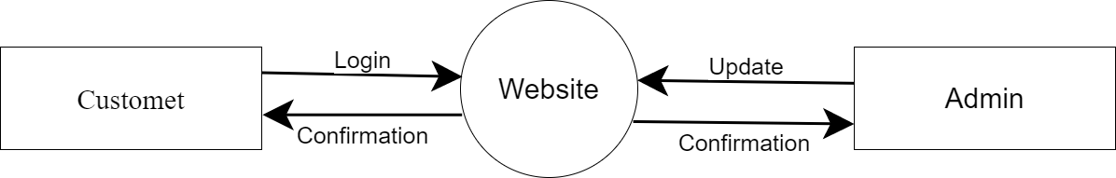

* + 1 Level

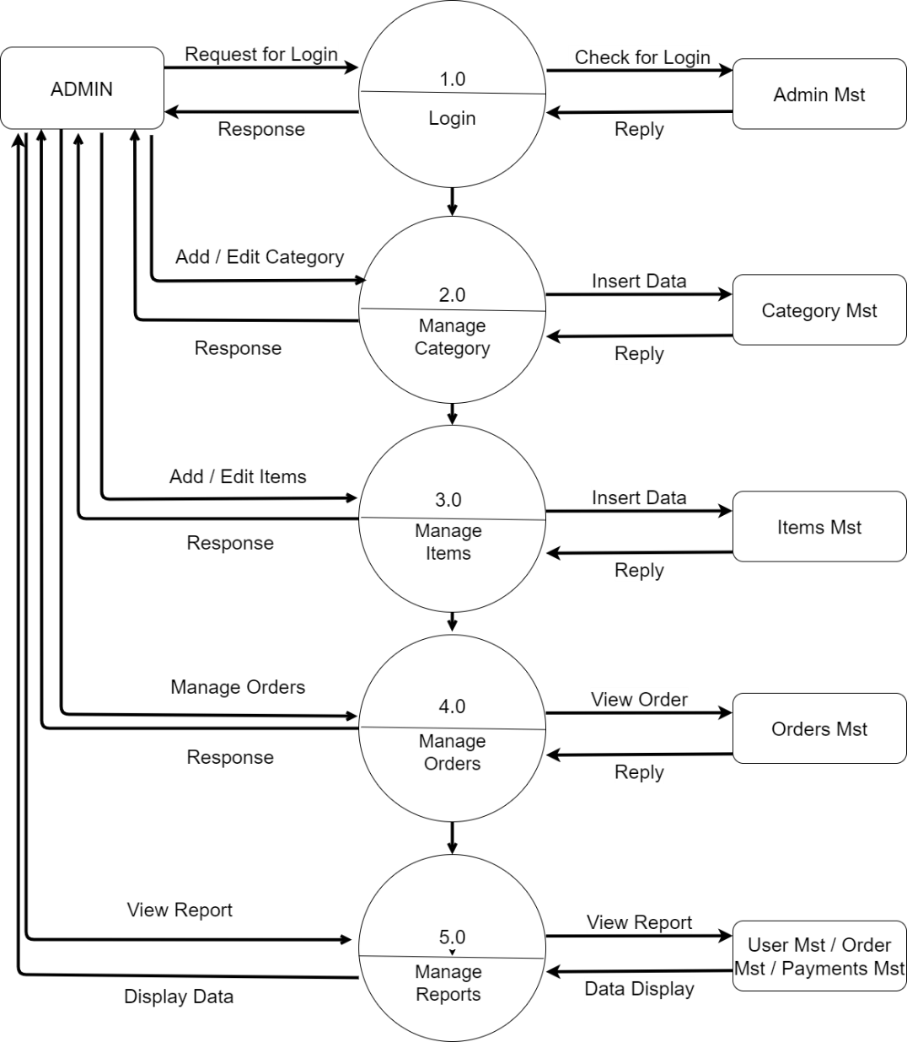

* + 2 Level

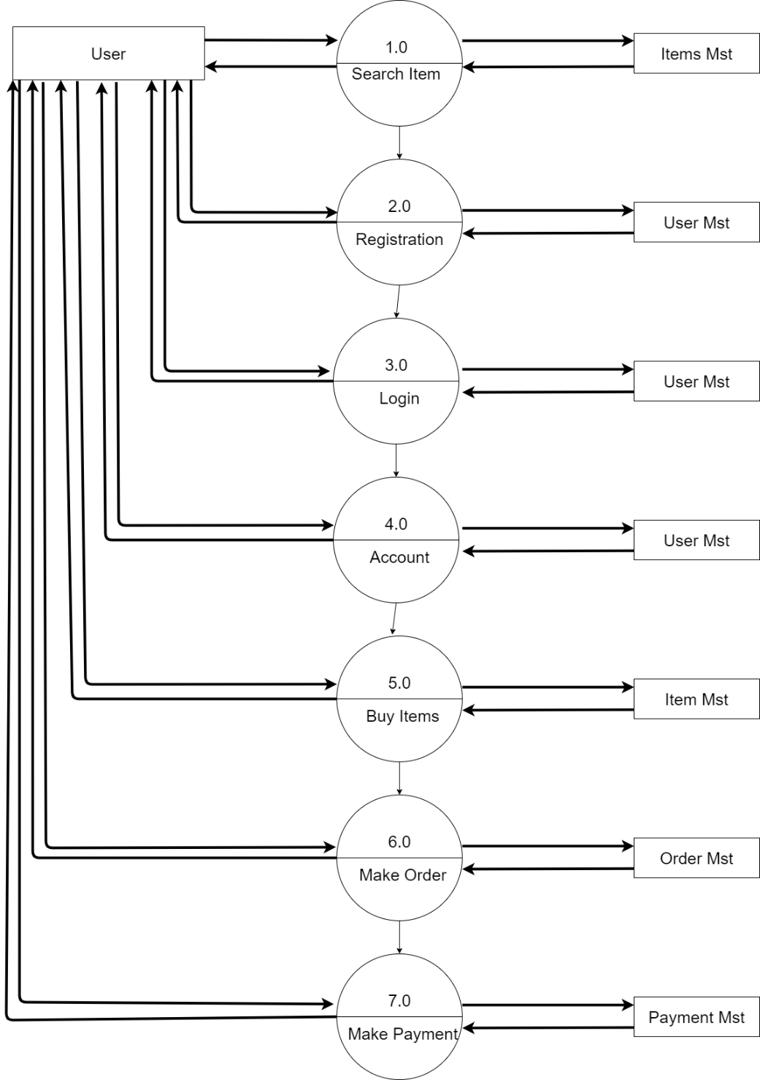

**Testing**

* Software testing is the process of evaluating and verifying that a software product or application does what it is supposed to do. The benefits of testing include preventing bugs, reducing development costs and improving performance.
* Test Plan
* Like any project, the testing also should be driven by a plan. The test plan generates the report for the execution and tracking of the entire testing project.
  + Preparing the test plan
* What needs to be the tested-the scope of testing, including clear identification of what will be the tested & what will not be tested.
* How the testing is going to be performed -breaking down the testing into small and manageable tasks and identifying the strategies to be used for carrying out the tasks.
* Resource needed for testing
* The timelines by which the testing activities will be performed.
* Risks that may be faced in all of the above, with appropriate mitigation and contingency plans.
* Testing Strategy
* Writing a Test Strategy effectively is a skill that every tester should achieve in their career. It initiates your thought process that helps to discover many missing requirements. Thinking and test planning activities help the team to define the Testing scope and Test coverage.
* It helps Test managers to get the clear state of the project at any point. The chances of missing any test activity are very low when there is a proper test strategy in place.
* Test execution without any plan rarely works. I know teams who write strategy document but never refer back while test execution. The Testing Strategy plan must be discussed with the whole team so that the team will be consistent with its approach and responsibilities.
* In tight deadlines, you can’t just waive any testing activity due to time pressure. It must at least go through a formal process before doing so.
* Testing methods
* Testing methodologies are the strategies and approaches used to test a particular product to ensure it is fit for purpose. Testing methodologies usually involve testing that the product works in accordance with its specification, has no undesirable side effects when used in ways outside of its design parameters, and will fail safely in the worst-case scenario.
* As software applications get ever more complex and intertwined and with the large number of different platforms and devices required to test, it is more important than ever to have a robust testing methodology.
* Without the proper development and testing methodologies for modern software, projects will inevitably go over budget, take longer than necessary, and not meet stakeholder expectations.
  + Two Types of Testing

1. Functional Testing

typically broken down into four components (unit testing, integration testing, system testing, and acceptance testing), this verifies that the functions and features of the software work as intended.

1. Non-Functional Testing

on the other hand, non-functional testing involves testing basically everything else like performance and customer expectations.

* Testing Cases

|  |  |
| --- | --- |
| **Test Case Specification** | **Description** |
| Test Case ID | Unique ID to identify/report the bug if present in the functionality of software |
| Test Case Objective | The purpose of the test. The lists can be generated to perform intended task, for which software is developed. Results should always follow the test case objective |
| Pre-requisite | This can include environment setup, supporting software environment setup. for the project, or any fields in which user will give the input. So that test cases can be planned accordingly. |
| Steps | This includes steps to be performed to give the input to the system, so that system can perform its specified task and display the result accordingly. If automated testing is used, then, these steps are translated to the scripting language of the tool. |
| Input Data | The choice of input data will be depended on the test case itself and the technique followed in the test case. For E.X. equivalence partitioning, boundary value analysis etc. |
| Expected Result | It can be the user required output to be shown |
| Actual Result | This step should do a comparison of the expected and actual results to highlight any differences. |
| Status | Whether expected results and actual result match, if it matches then PASS or else FAIL |

**Screen short**

* Home page

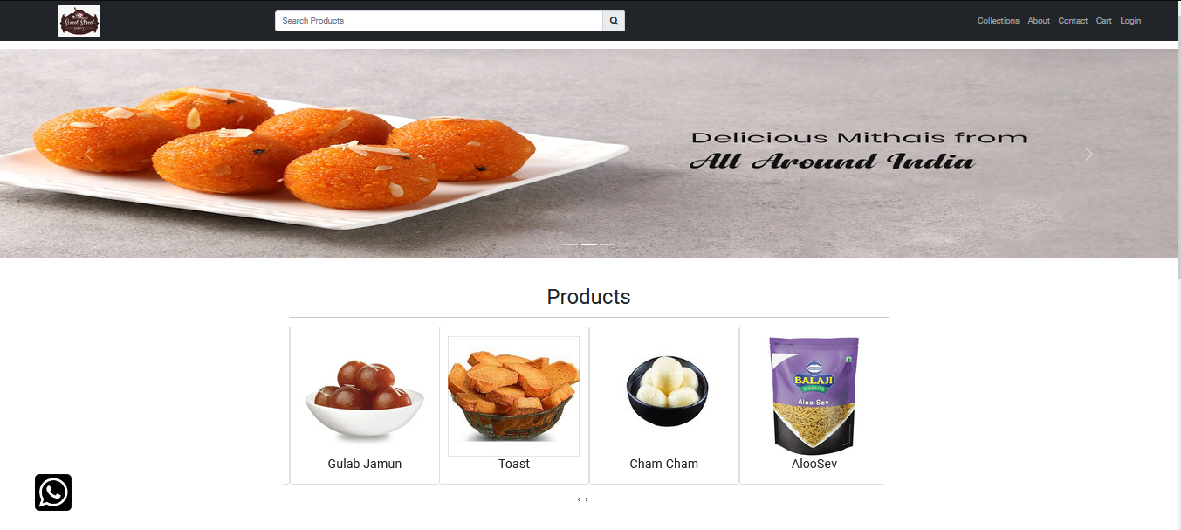

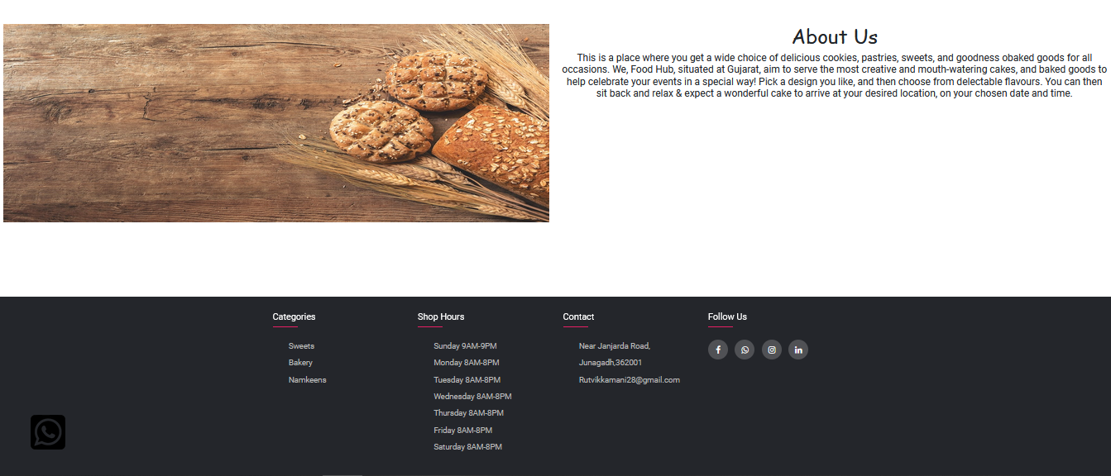

This is home page

* Category page

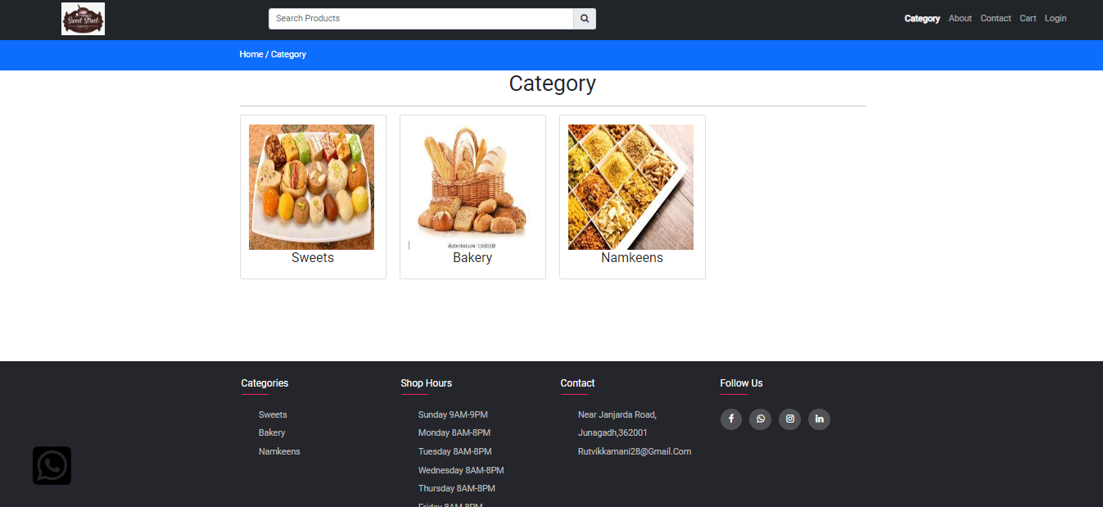

This is Show all Category page

* View Category

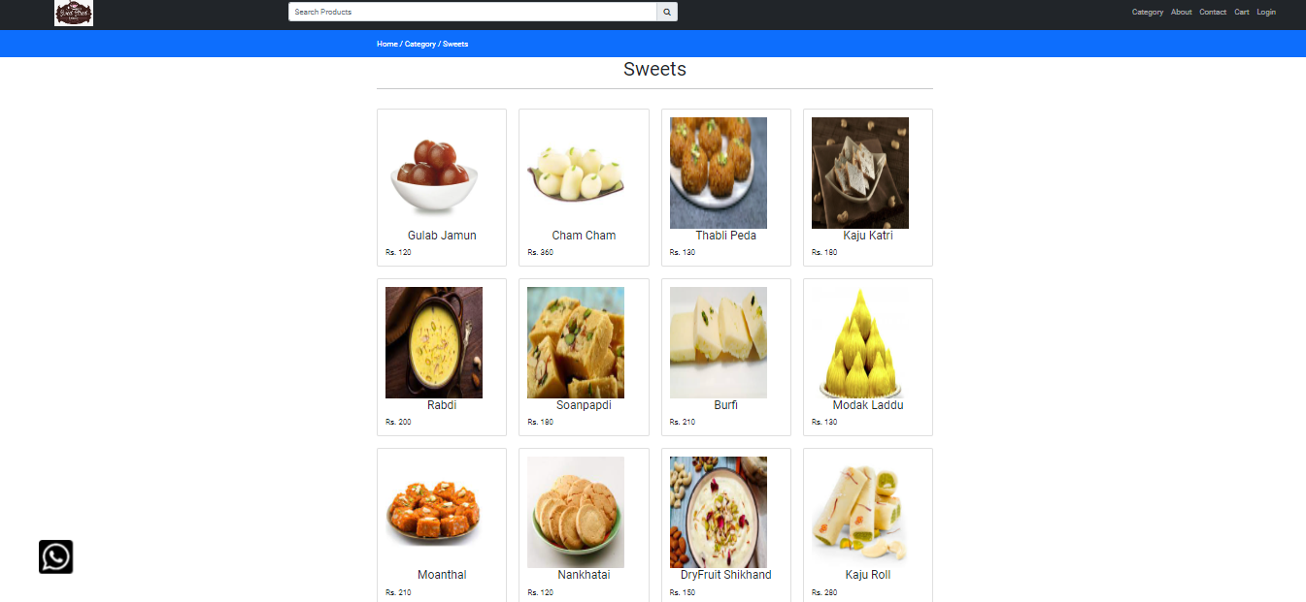

This is view specific category page

* View Item

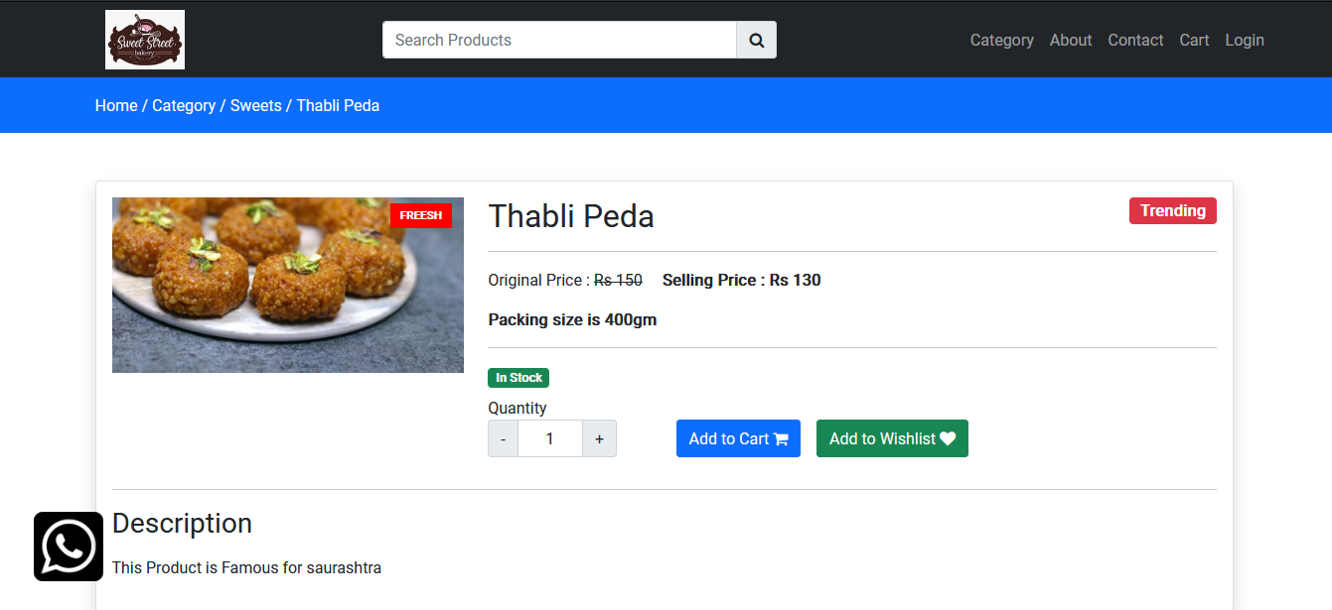

This is user purchase item page

* About Page

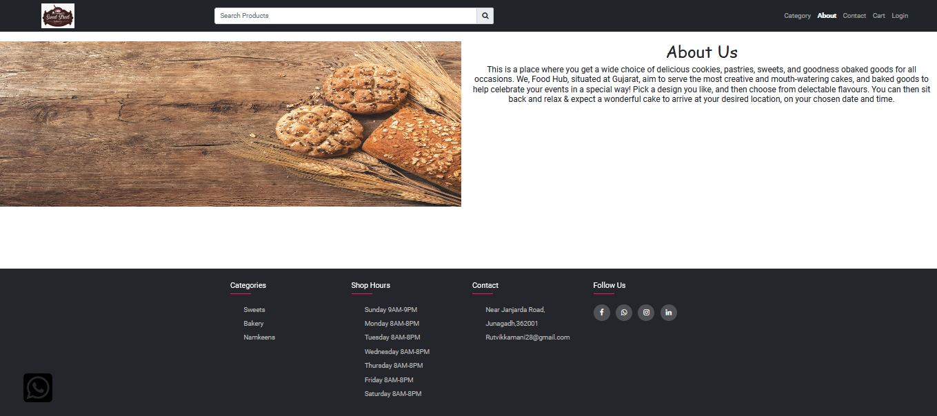

This is About page

* Contact Page

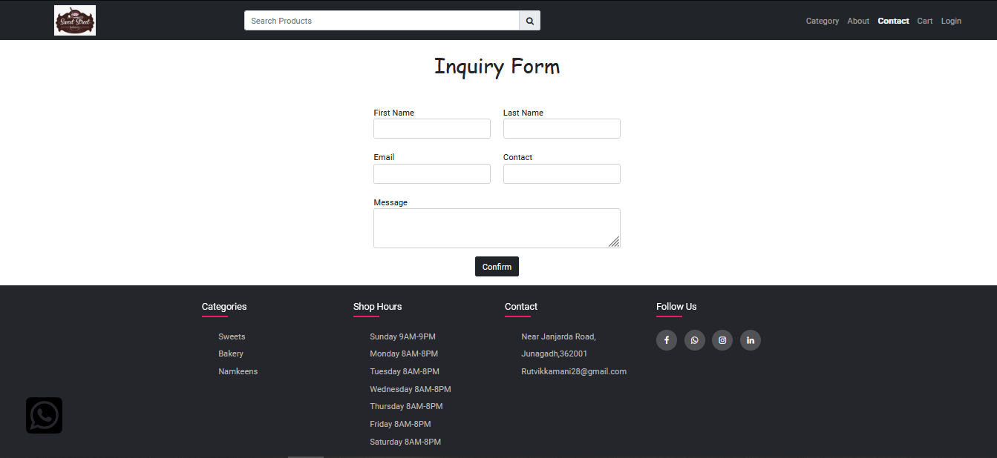

This is user inquiry page

* Register Page

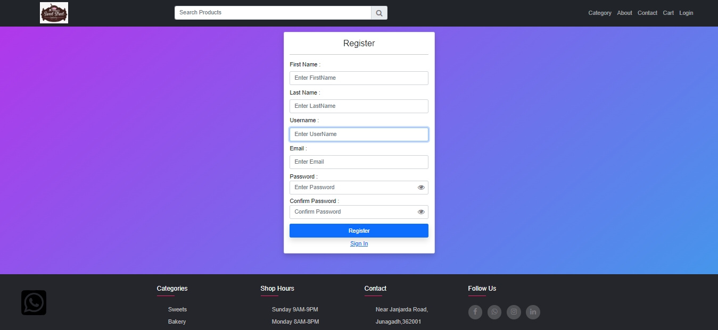

This is user register page

* Login Page

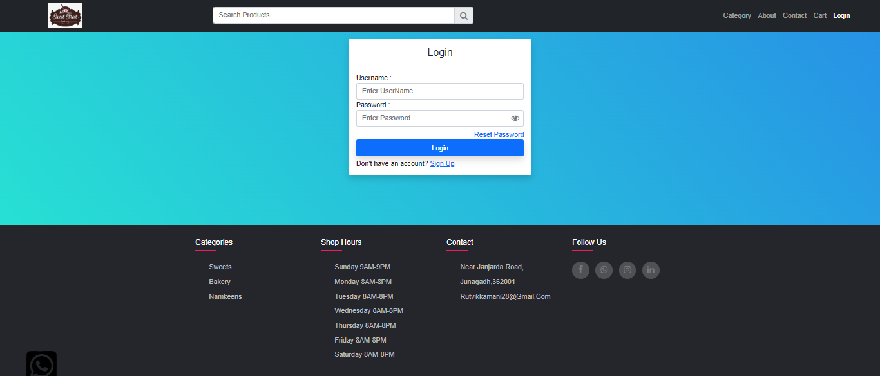

This is user login page

* User Admin Dashboard

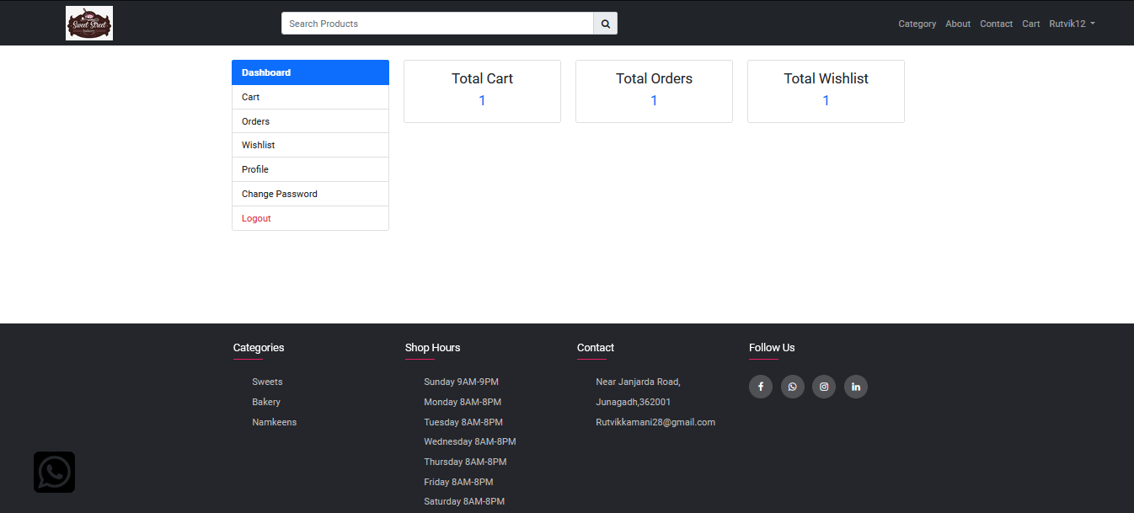

This is user show dashboard page

* Cart Page

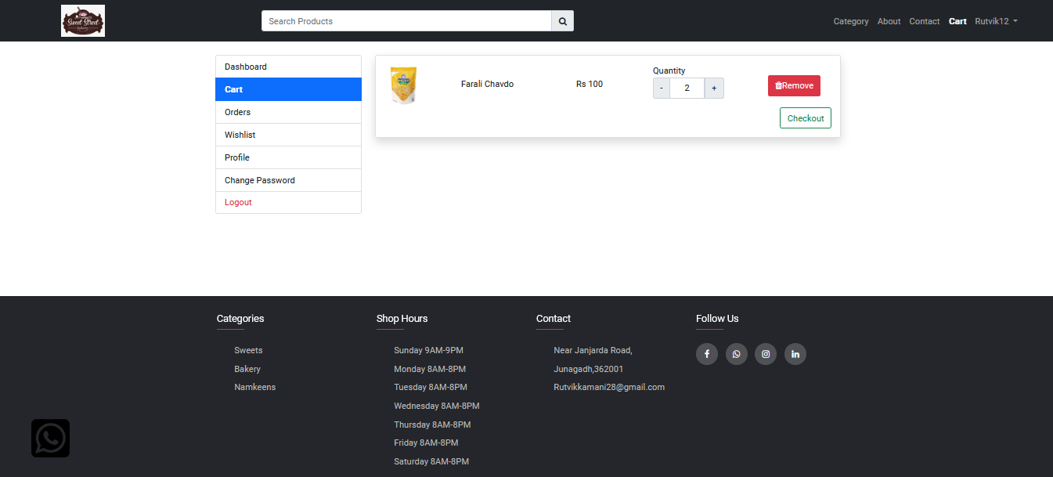

This is show No of Product in cart for user

* Order Placed Page

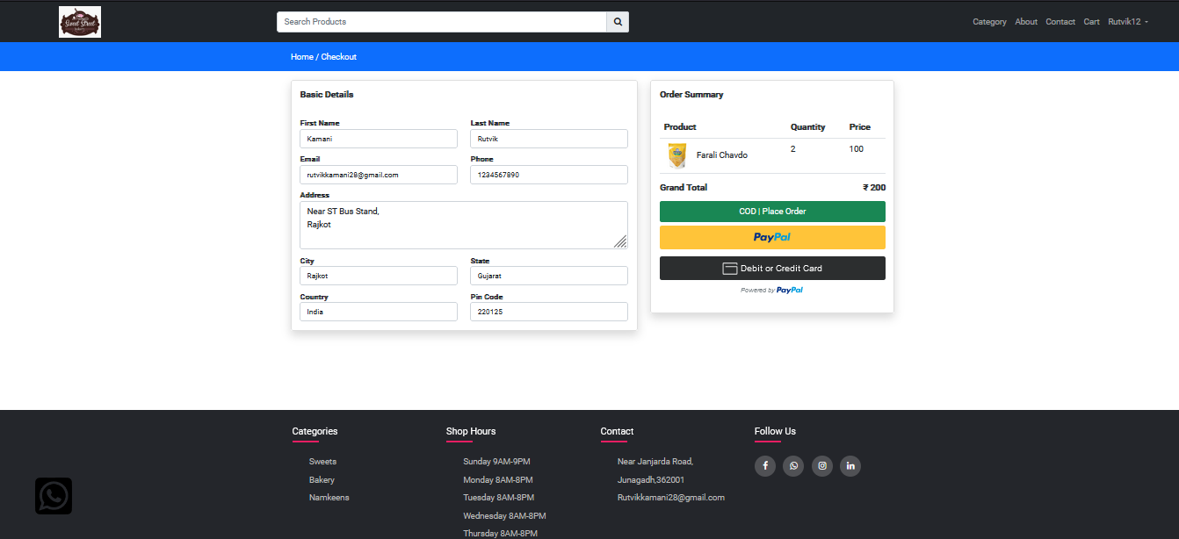

This is order place page

* Paypal Payment Gateway

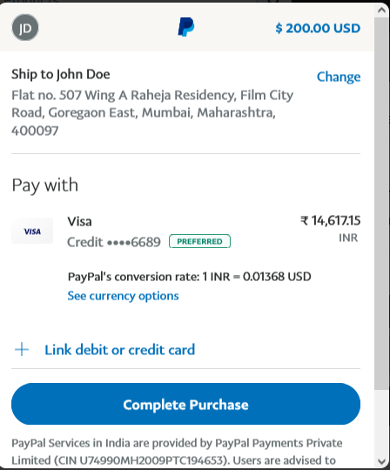

This is Paypal payment gateway user pay online money page

* Order Page

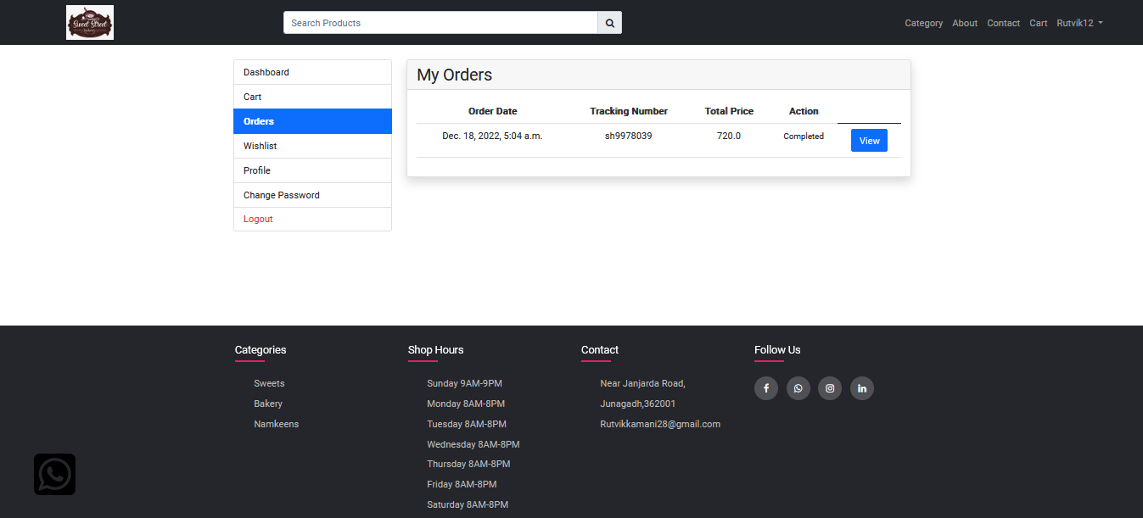

This is show all order for user

* Order View

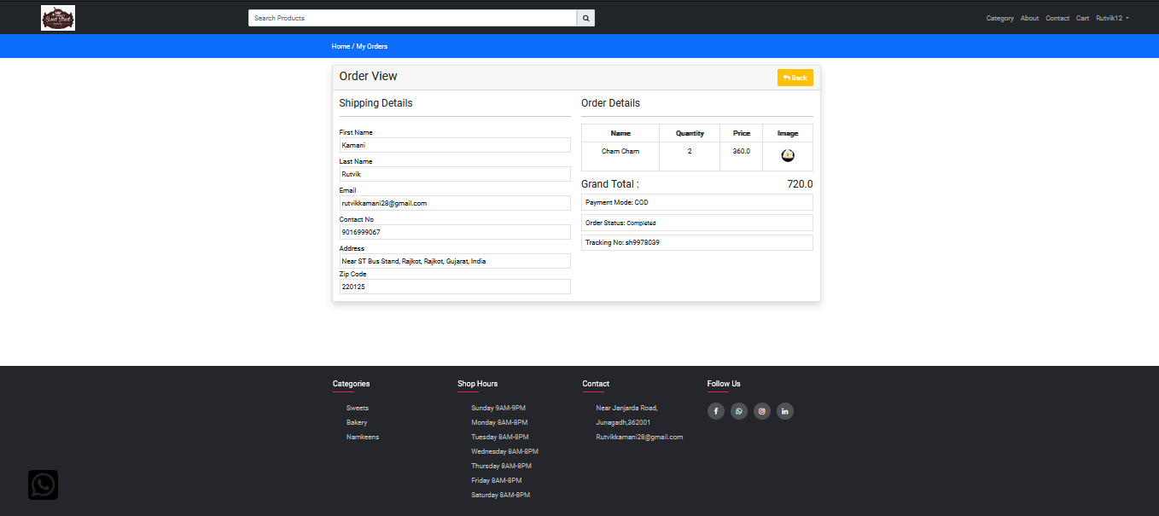

This is show user purchase product order view

* Wishlist Page

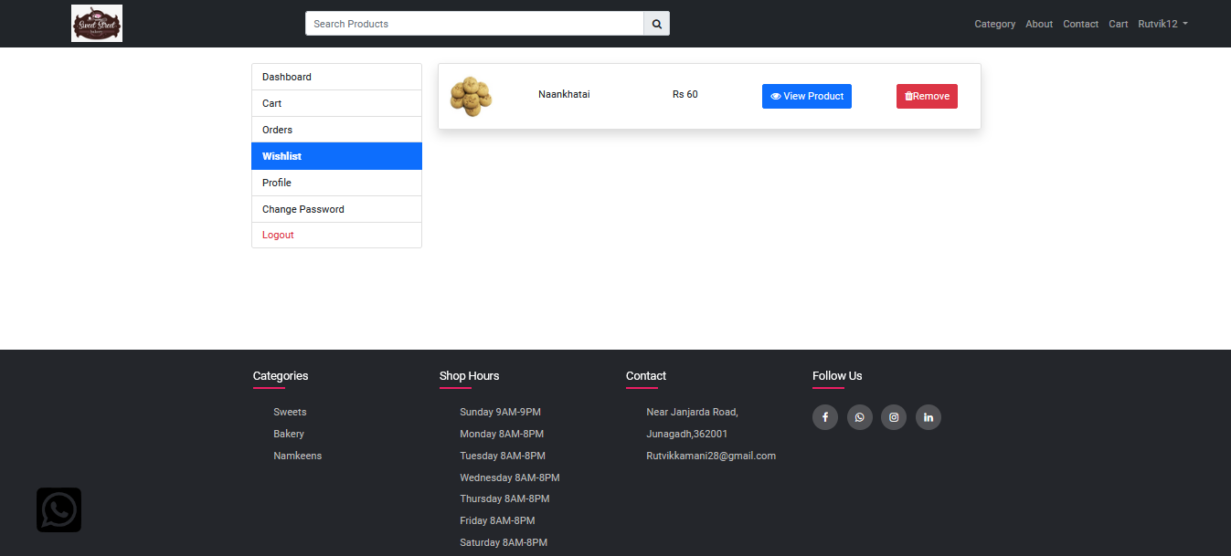

This is user wishlist page

* Profile Page

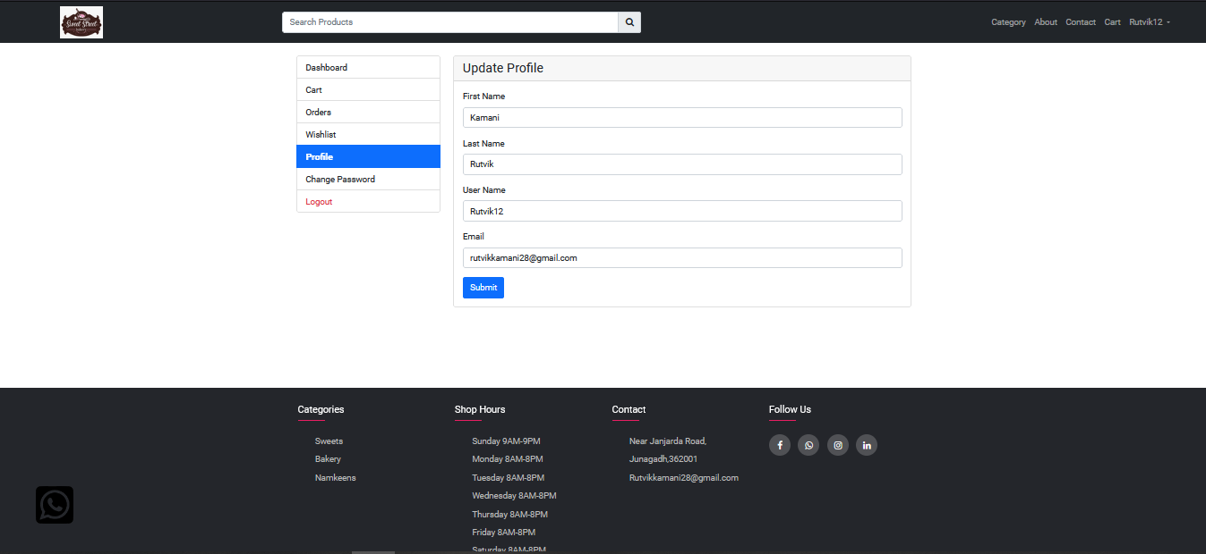

This is user profile page

* Change Password

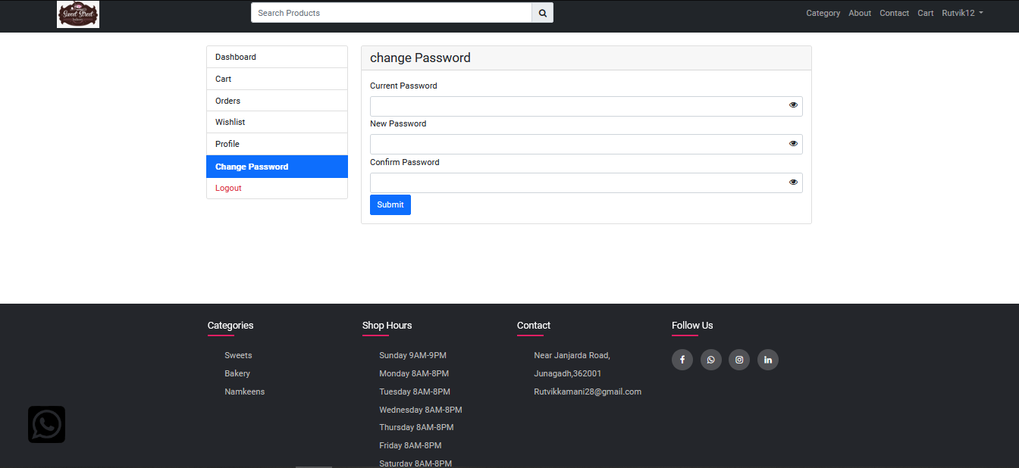

This is change password for user page

* Admin Panel

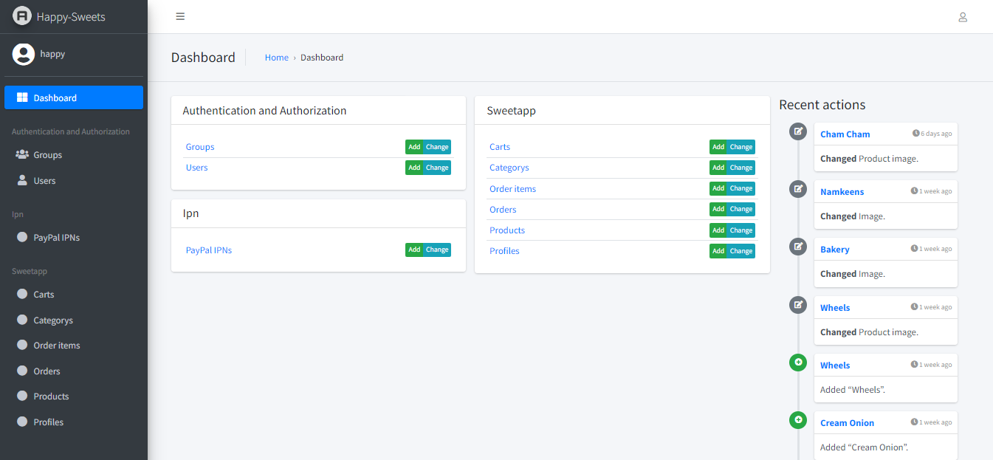

This is Show Admin Panels Page

* Cart Page

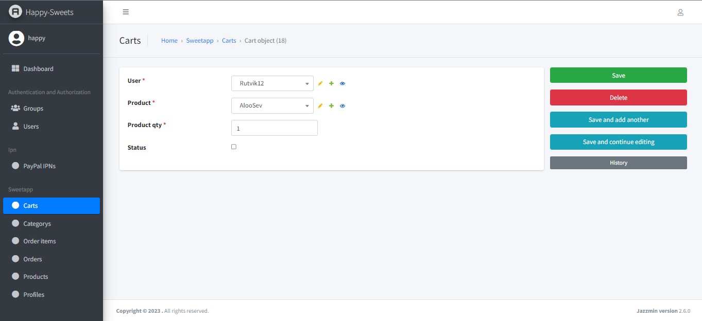

This is Show All Cart for User

* Category Page

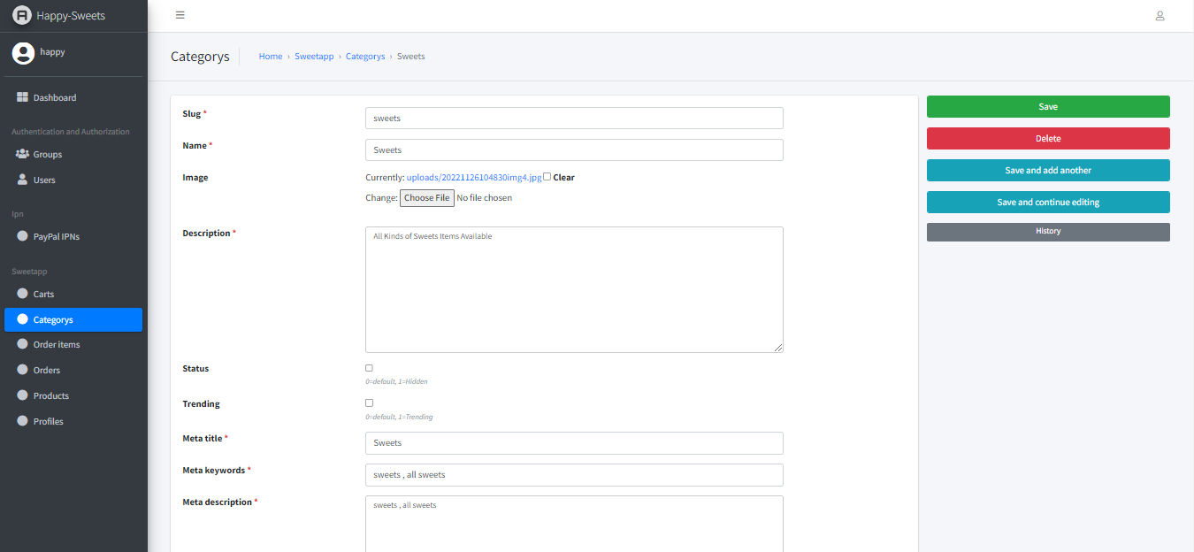

This is Add Category page

* Order Items

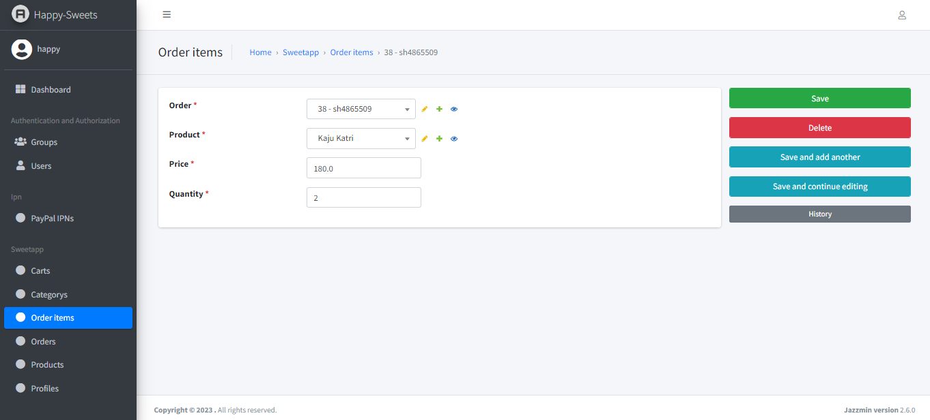

This is show User Perchase Item

* Order Page

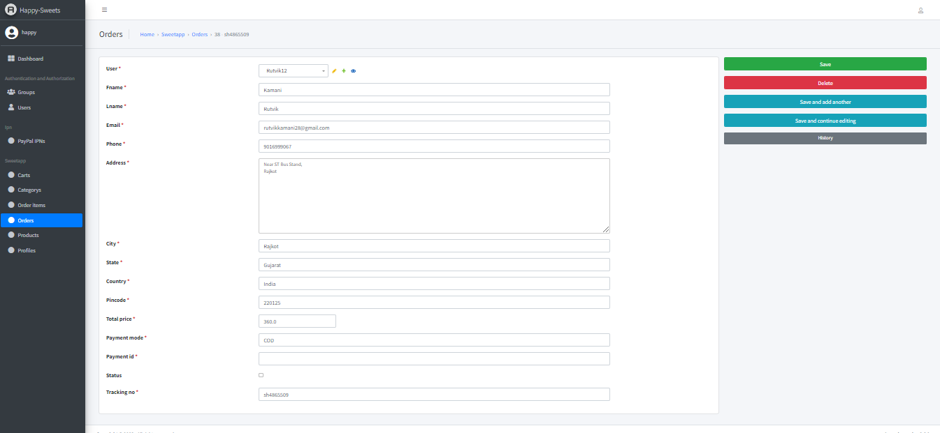

This is show user details for purchase order

* Product Page

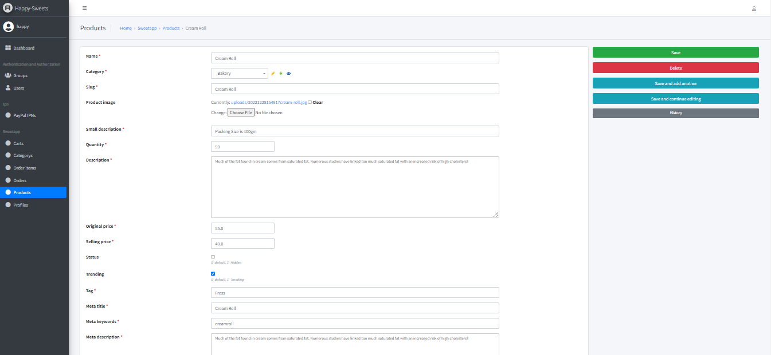

This is Add Product Page

* Profile Page

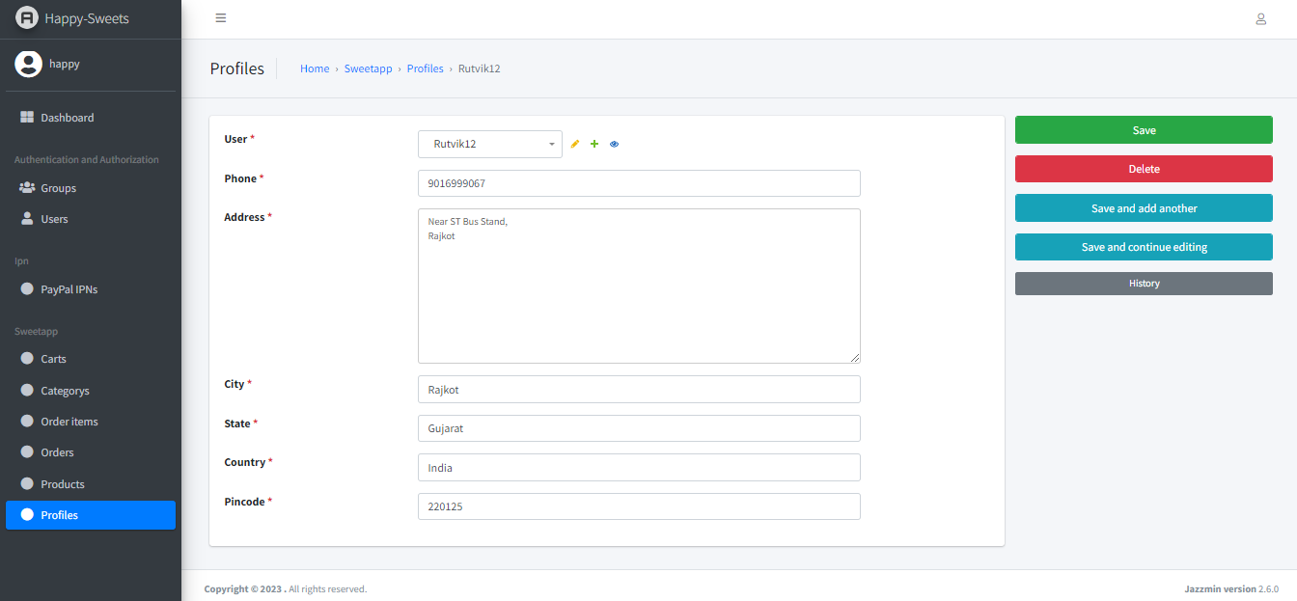

This is Show User Profile Page

**Limitation & future enhancement**

* The limitations of a study are its flaws or shortcomings. Study limitations can exist due to constraints on research design, methodology, materials, etc., and these factors may impact the findings of your study.
* However, researchers are often reluctant to discuss the limitations of their study in their papers, feeling that bringing up limitations may undermine its research value in the eyes of readers and reviewers.
* In spite of the impact it might have (and perhaps because of it) you should clearly acknowledge any limitations in your research paper in order to show readers whether journal editors, other researchers, or the general public that you are aware of these limitations and to explain how they affect the conclusions that can be drawn from the research.
* There is scope for future development of this project. The world of computer fields is not static; it is always subject to be dynamic. The technology which is famous today becomes outdated the very next day.
* To keep abstract of technical improvements, the system may be further refined. So, it is not concluded. Yet it will improve with further enhancements.

**Conclusion and discussion**

* A conclusion is the final piece of writing in a research paper, essay, or article that summarizes the entire work. The conclusion paragraph should restate your thesis, summarize the key supporting ideas you discussed throughout the work, and offer your final impression on the central idea.
* This final summation should also contain the moral of your story or a revelation of a deeper truth. A good conclusion will wrap up your final thoughts and main points, combining all pertinent information with an emotional appeal for an ending statement that resonates with your readers.
* When you’re ready to write your discussion, you’ve already introduced the purpose of your study and provided an in-depth description of the methodology. The discussion informs readers about the larger implications of your study based on the results.
* Highlighting these implications while not overstating the findings can be challenging, especially when you’re submitting to a journal that selects articles based on novelty or potential impact. Regardless of what journal you are submitting to, the discussion section always serves the same purpose: concluding what your study results actually mean.

**References**

* Search Engines
* [**https://www.google.com/**](https://www.google.com/)
* Visited Sites
* [**https://docs.djangoproject.com/en/4.1/**](https://docs.djangoproject.com/en/4.1/)
* [**https://www.geeksforgeeks.org/django-tutorial/**](https://www.geeksforgeeks.org/django-tutorial/)
* [**https://stackoverflow.com/**](https://stackoverflow.com/)
* [**https://www.tutorialspoint.com/django/**](https://www.tutorialspoint.com/django/)